SIMATS ENGINEERING
ASSESSMENT TOOL 3: Application Based Questions
COURSE NAME: | Cloud Computing and Big Data Analytics | COURSE CODE: | CSA15

COURSE OUTCOME COVERED
CO2: Analyze virtualization architectures to identify performance and security issues in cloud computing environments. (BL3)
Dave's Taxonomy: Manipulation (Level 2) Total Marks: 25
Question Count: 5

Code of Conduct
I Kaviya .G / 192524281 (Name / Reg No) certify that this submission is my original work and that I have adhered to the guidelines specified for this assessment.
I understand that any violation of academic integrity rules will result in disciplinary action.
Signature of the student: Kaviya .G
Assessment Tasks
Application Based Questions
- A company experiences unpredictable traffic spikes during seasonal sales. Explain how cloud auto-scaling and load balancing can handle this demand efficiently. How does this approach reduce downtime and improve user experience? What role do monitoring tools play in this setup? Relate your answer to a real-world e-commerce scenario.
Answer 1:
Seasonal sales such as Diwali, Big Billion Days, Black Friday or Prime Day can raise traffic many times above normal, and the peak is hard to predict. A fixed on-premise server farm is either over-provisioned (wasted money) or under-provisioned (crashes). Cloud computing solves this with elasticity: Auto-Scaling adds or removes servers automatically and a Load Balancer shares requests among them.
1. Cloud Auto-Scaling
- Definition: A service that automatically increases (scale-out) or decreases (scale-in) the number of virtual machines/containers based on demand, within a defined minimum, desired and maximum limit.
- Horizontal scaling: More identical web servers are launched from a template (image) when load rises; extra servers are terminated when load falls, so the company pays only for what it uses.
Scaling Policy | How it works | Use in e-commerce sale
Target tracking | Keeps a metric (e.g. CPU = 60%) near a target value | Handles sudden, unpredictable spikes
Step scaling | Adds servers in steps as an alarm threshold is crossed | Flash sale with rapid growth
Scheduled scaling | Capacity is raised at a fixed date/time | Pre-warm before the 12:00 AM sale launch
Predictive scaling | Uses past traffic patterns (ML) to forecast load | Annual festival season

2. Load Balancing
- Traffic distribution: The load balancer (e.g. AWS ALB/ELB, Azure Load Balancer, GCP Cloud Load Balancing) receives all user requests and forwards each one to a healthy server using algorithms such as round robin, least connections or weighted routing.
- Health checks: Unhealthy servers are removed from rotation automatically, so users never reach a failed server.
- Other features: Multi-AZ distribution, SSL/TLS termination, session persistence (sticky sessions) and path-based routing (/cart, /payment).
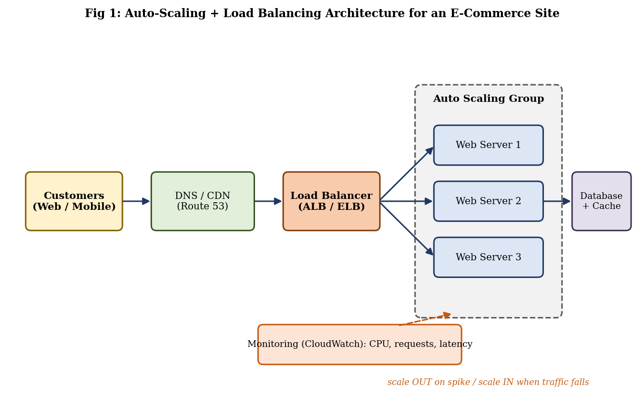
Fig 1: Auto-scaling and load balancing architecture
3. How the System Works During a Sale
- Customers reach the site through DNS and CDN; the load balancer receives the requests.
- Monitoring detects CPU/request count crossing the threshold (e.g. CPU > 60%).
- Auto Scaling launches new web servers; they pass health checks and register with the load balancer.
- Load is spread evenly, so response time stays low.
- When the sale ends, extra servers are terminated (scale-in) to save cost.
4. Reduction of Downtime and Better User Experience
Aspect | Without Auto-Scaling / LB | With Auto-Scaling / LB
Capacity | Fixed; server overload and crash at peak | Elastic; grows with demand automatically
Availability | Single point of failure | Multi-AZ, failed servers replaced (self-healing)
Response time | Slow pages, time-outs, cart loss | Consistent low latency, smooth checkout
Cost | Pay for peak capacity all year | Pay-per-use; scale-in after sale
Maintenance | Downtime for upgrades | Rolling updates with no outage

Because there is no single point of failure and capacity matches demand, the site stays available (higher uptime/SLA), pages load fast, payments do not fail and customers are less likely to abandon their carts, which directly improves sales and brand trust.
5. Role of Monitoring Tools
Monitoring tools (Amazon CloudWatch, Azure Monitor, Google Cloud Monitoring, Prometheus + Grafana, Datadog) collect metrics and logs continuously and act as the “eyes” of the setup.
Metric monitored | Alarm / Action
CPU utilisation, memory | Trigger scale-out / scale-in policy
Request count, latency, error rate (5xx) | Alert operations team; investigate bottleneck
Healthy host count | Replace unhealthy instances automatically
Database connections, cache hit ratio | Scale database / add read replicas
Billing / cost metrics | Budget alerts to avoid overspending

6. Real-World E-Commerce Scenario
An online retailer such as Flipkart or Amazon expects a mega-sale at midnight. The team schedules extra capacity just before launch and sets a target-tracking policy at 60% CPU. When traffic jumps from about 20 servers’ worth of load to many times more, Auto Scaling adds servers in minutes, the Application Load Balancer spreads the shoppers across Availability Zones, and CloudWatch dashboards and alarms keep engineers informed. Shoppers browse, add to cart and pay without slowdown; after the sale the fleet shrinks back and the cost drops.
Conclusion
Auto-scaling gives elasticity, load balancing gives even distribution and fault tolerance, and monitoring ties them together. Together they deliver high availability, a better user experience and cost efficiency during unpredictable seasonal demand.
- An organization wants to store large volumes of backup data securely in the cloud. Discuss how cloud storage solutions ensure durability and data redundancy.
How can encryption and access control protect sensitive backup data?
Explain the cost advantages compared to traditional storage systems.
Provide an example of a disaster recovery use case.
Answer 2:
Cloud object/block storage services (Amazon S3, Azure Blob Storage, Google Cloud Storage) are designed to hold petabytes of backup data with very high durability, strong security and pay-as-you-go cost.
1. Durability and Data Redundancy
- High durability: Object storage is typically designed for 99.999999999% (eleven nines) durability, meaning the chance of losing an object is extremely small.
- Replication: Each object is automatically stored as multiple copies across several disks, servers and Availability Zones (data centres) in a region.
- Erasure coding and checksums: Data is split into fragments with parity; checksums detect corruption and the system self-heals from good copies.
- Versioning and cross-region replication: Old versions can be restored after accidental deletion, and a copy can be kept in another geographic region.
Redundancy option | Copies kept | Protects against
Locally redundant (LRS) | 3 copies in one data centre | Disk / rack failure
Zone redundant (ZRS / multi-AZ) | Copies in 3 Availability Zones | Entire data-centre failure
Geo redundant (GRS / cross-region) | Copies in two distant regions | Regional disaster (flood, fire, outage)

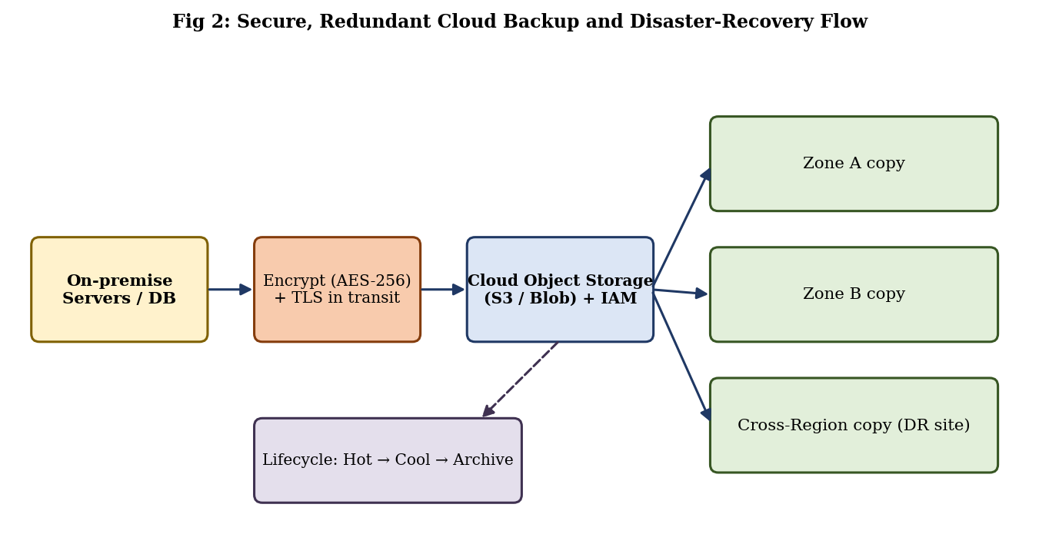
Fig 2: Secure, redundant cloud backup and disaster-recovery flow
2. Encryption and Access Control
- Encryption at rest: Backups are encrypted with AES-256, using provider-managed keys or customer-managed keys in a Key Management Service/HSM (SSE-KMS, BYOK).
- Encryption in transit: TLS/HTTPS or VPN/private links protect data while it travels from the organization to the cloud; client-side encryption can be added before upload.
- Access control: Identity and Access Management (IAM) with least-privilege roles, multi-factor authentication, bucket policies and “block public access” settings decide who can read, write or delete.
- Immutability: Object Lock / WORM and MFA-delete stop ransomware or insiders from deleting or altering backups.
- Auditing: Access logs (CloudTrail / Azure Monitor) record every action for investigation.
Control | Threat it prevents
AES-256 encryption at rest | Data theft from stolen disks or storage breach
TLS in transit | Interception / man-in-the-middle attack
IAM least privilege + MFA | Unauthorised or stolen-credential access
Object Lock (WORM) + versioning | Ransomware, accidental or malicious deletion
Logging and alerts | Undetected misuse; compliance gaps

3. Cost Advantages over Traditional Storage
Factor | Traditional (on-premise) storage | Cloud storage
Initial cost | High CapEx: buy disks, tape libraries, servers | No upfront cost (OpEx, pay-as-you-go)
Scalability | Buy extra hardware in advance; wasted capacity | Unlimited, scale instantly; pay for used GB only
Maintenance | Staff, power, cooling, space, hardware refresh | Handled by the provider
Disaster recovery site | Build and run a second data centre | Built-in multi-AZ / cross-region copies
Cost optimisation | Same cost for all data | Tiering: Hot → Cool → Archive (Glacier) lowers cost for old backups
Durability | Depends on own RAID/tape handling | 11-nines durability included

4. Disaster Recovery Use Case
A hospital keeps patient records and imaging backups encrypted in cloud storage, replicated to a second region. One night ransomware encrypts the main servers (or a fire damages the data centre). The IT team isolates the infected systems, selects the last clean, immutable backup version and restores it to virtual machines in the secondary region. Services resume within the target Recovery Time Objective (RTO) and lose only the data since the last backup (Recovery Point Objective, RPO).
DR strategy | RTO / RPO | Relative cost
Backup and Restore | Hours / hours | Lowest
Pilot Light | Tens of minutes to hours | Low
Warm Standby | Minutes | Medium
Multi-site Active-Active | Near zero | Highest

Conclusion
Cloud storage offers durable, redundant, encrypted and access-controlled backups at a lower, usage-based cost, and it makes disaster recovery faster and cheaper than maintaining a second physical site.
- A mobile app company plans to deploy its application globally. Explain how content delivery networks (CDNs) improve performance and reduce latency. How do edge servers enhance user experience across regions? Discuss how cloud providers support global availability. Relate this to a real-time streaming or gaming application.
Answer 3:
A Content Delivery Network (CDN) is a geographically distributed network of servers (Points of Presence) that cache and deliver content from a location close to the user. Latency depends heavily on distance, so serving a user in India from a server in the USA is slow; a CDN removes most of that distance.
1. How CDNs Improve Performance and Reduce Latency
- Caching near the user: Images, videos, scripts, app updates and API responses are cached at edge locations, so most requests never reach the origin.
- Smart routing: DNS or Anycast sends each user to the nearest, least-loaded edge server.
- Optimisation: Compression, HTTP/2 and HTTP/3, TCP/TLS connection reuse and image optimisation reduce load time.
- Origin offload: Fewer requests hit the origin, saving bandwidth and preventing overload.
- Security: DDoS absorption, WAF and TLS termination at the edge.
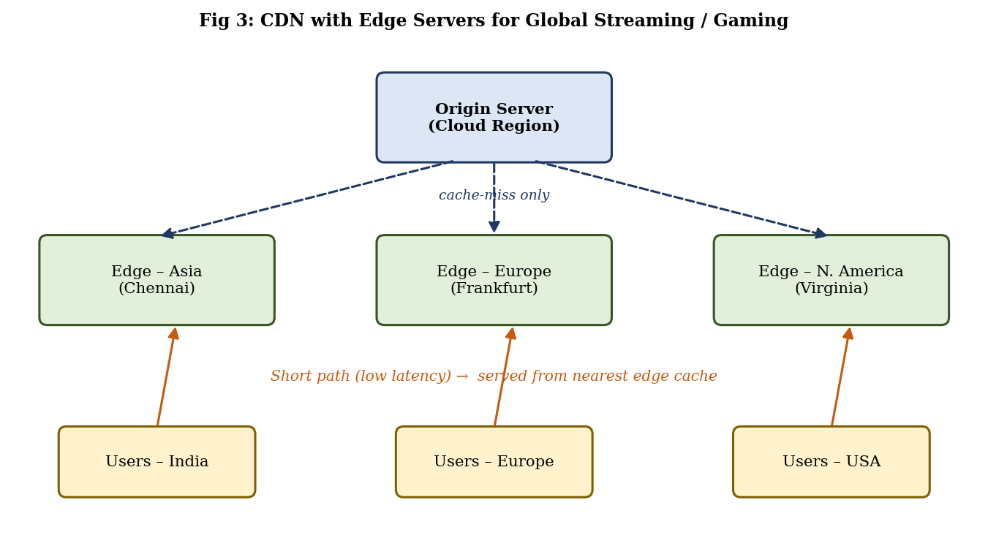
Fig 3: CDN with edge servers for global streaming/gaming
Parameter | Without CDN | With CDN
Content source | Single origin server far away | Nearest edge cache
Latency | High (long network path) | Low (short path)
Origin load | Every request hits origin | Only cache-misses reach origin
Peak traffic | Bandwidth bottleneck, buffering | Spread across many edge servers
Reliability | Origin failure = outage | Cached content still served

2. Role of Edge Servers in User Experience Across Regions
- Faster loading and start-up: Content is served from the same city or country as the user, so app screens and videos start quickly.
- Consistent quality: Users in Asia, Europe and America get similar performance; adaptive bitrate keeps video smooth on weak networks.
- Edge computing: Small functions (authentication checks, personalisation, A/B tests, geo-blocking) run at the edge (Lambda@Edge, Cloudflare Workers).
- Resilience: If one edge node fails, traffic shifts to another automatically.
3. How Cloud Providers Support Global Availability
Feature | Description
Regions and Availability Zones | Dozens of regions worldwide, each with multiple isolated data centres for fault tolerance
Global load balancing / DNS | Latency-based or geo-routing (Route 53, Azure Traffic Manager, Cloud Load Balancing) sends users to the nearest healthy region
Multi-region deployment | Application servers run in several regions; automatic failover when a region fails
Global databases | Replication across regions (DynamoDB Global Tables, Cosmos DB, Spanner) keeps data close to users
Global edge network and backbone | Private high-speed backbone and hundreds of CDN edge locations
SLA and monitoring | Uptime guarantees (e.g. 99.99%) and health monitoring

4. Real-Time Streaming / Gaming Application
Application | How CDN / edge / global cloud helps
Video streaming (Netflix, Hotstar, YouTube) | Video is cut into small segments cached on edge/ISP servers; adaptive bitrate streaming switches quality automatically; millions of viewers during a live match are served without buffering
Online gaming (PUBG / BGMI, Fortnite) | Game patches and assets download from the CDN; matchmaking sends players to the nearest regional game server for low ping; edge nodes reduce lag and jitter

Thus a mobile app company that launches worldwide should place static content on a CDN, deploy backend services in multiple regions, and use global load balancing so every user, wherever located, receives low-latency and highly available service.
Conclusion
CDNs and edge servers cut latency and offload the origin, while cloud regions, global load balancing and replication provide worldwide availability, giving a smooth real-time experience for streaming and gaming users.
- A financial institution requires strict compliance and data security in cloud usage.
Explain how cloud providers support regulatory compliance and auditing. What role do logging, monitoring, and encryption play in security? How can the company ensure data sovereignty requirements are met? Give an example involving sensitive financial transactions.
Answer 4:
Banks and financial institutions must follow strict rules (PCI DSS, ISO 27001, SOC 2, GDPR, RBI/SEBI guidelines). Cloud providers help by giving certified infrastructure and built-in security tools, but compliance is a shared effort.
1. How Cloud Providers Support Compliance and Auditing
- Certified infrastructure: Data centres are audited for ISO 27001/27017/27018, SOC 1/2/3, PCI DSS, HIPAA and regional standards; reports are available through portals such as AWS Artifact or Azure Compliance Manager.
- Policy and configuration tools: AWS Config, Azure Policy and Google Security Command Center check resources continuously against compliance rules.
- Audit trails: Every API call and login is recorded (CloudTrail, Azure Activity Log, Cloud Audit Logs) for auditors.
- Physical security and redundancy: Controlled data-centre access, background-checked staff and certified disposal of media.
Shared responsibility | Cloud provider | Financial institution (customer)
Physical data centre, hardware, network | Yes | No
Hypervisor / base platform security | Yes | No
Identity and access management | Provides tools | Configures users, roles, MFA
Data classification and encryption keys | Provides services | Chooses, manages and rotates keys
Application security and compliance evidence | Provides tools and reports | Implements controls, runs audits

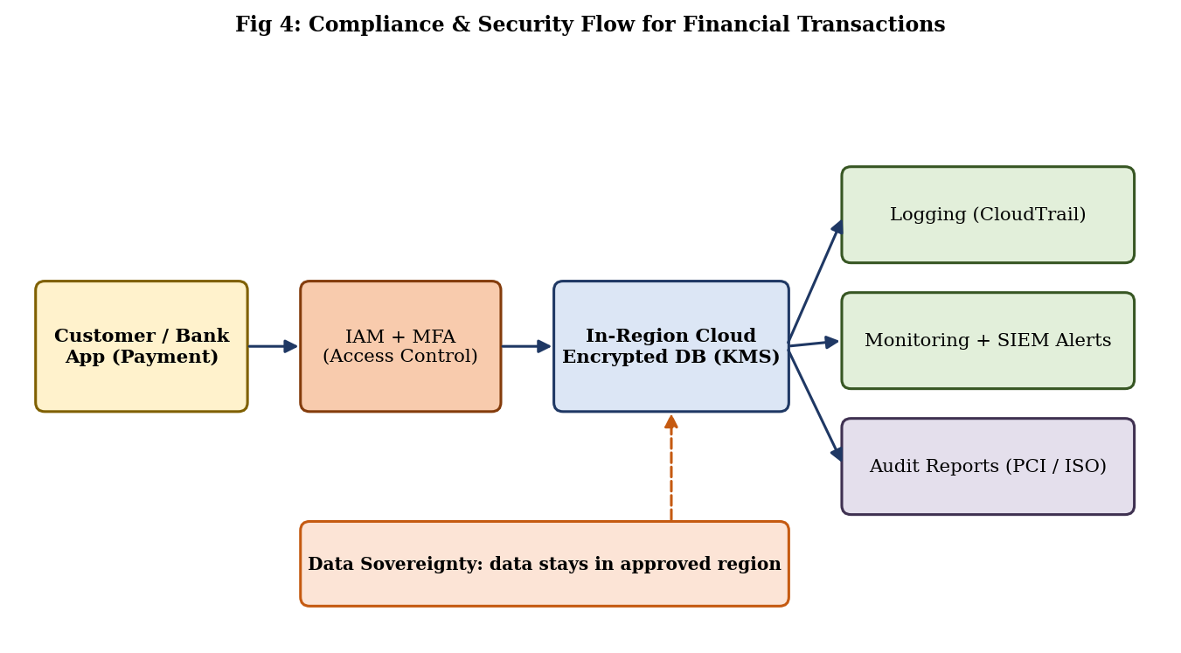
Fig 4: Compliance and security flow for financial transactions
2. Role of Logging, Monitoring and Encryption
Component | Role in security | Example tools
Logging | Records who did what and when; supports forensic investigation and audit evidence; logs are stored immutably | CloudTrail, VPC Flow Logs, Azure Activity Log
Monitoring | Detects unusual activity in real time (failed logins, large transfers) and raises alerts; supports SIEM correlation | CloudWatch, Azure Sentinel, GuardDuty, Splunk
Encryption | Protects data at rest (AES-256), in transit (TLS 1.2+) and in use; keys kept in KMS/HSM with rotation | AWS KMS, Azure Key Vault, Cloud HSM
Access control | MFA, least privilege, network segmentation, private endpoints | IAM, RBAC, security groups

3. Ensuring Data Sovereignty
Data sovereignty means data is subject to the laws of the country where it is stored (for example, RBI requires payment data of Indian customers to be stored only in India).
- Region selection: Deploy and store data only in approved regions (e.g. Mumbai / Hyderabad) and disable replication outside them.
- Policy guardrails: Service Control Policies / Azure Policy deny creation of resources in non-approved regions.
- Local key control: Keep encryption keys in an in-country HSM or use customer-managed keys (BYOK/HYOK) so the provider cannot decrypt without permission.
- Contracts and certifications: Data Processing Agreements, provider commitments on data location, local sovereign or government cloud options and regular audits.
4. Example: Sensitive Financial Transactions
A customer pays ₹50,000 through a bank’s mobile app (UPI / card). The request travels over TLS to the bank’s application in an Indian cloud region. IAM + MFA ensure only authorised services access the database; card data is tokenised and stored encrypted with keys in a local HSM. CloudTrail logs every access, the monitoring system raises an alert if a suspicious pattern (e.g. many high-value transfers) appears, and an audit report supports PCI DSS and RBI inspections. Backups are replicated only to another Indian region, so data sovereignty is preserved.
Conclusion
By combining provider certifications, shared-responsibility controls, strong logging, monitoring and encryption, and strict regional policies, a financial institution can meet compliance and sovereignty requirements while using the cloud.
- A development team wants to adopt containerization for application deployment.
Explain how containers differ from virtual machines in terms of performance and resource usage. How does orchestration (like Kubernetes) simplify deployment and scaling? Discuss portability benefits across different cloud environments.
Provide an example of a microservices-based application.
Answer 5:
A container packages an application with its libraries and dependencies into a lightweight, isolated unit (e.g. Docker image) that shares the host operating-system kernel. A virtual machine (VM) includes a full guest operating system running on a hypervisor.
1. Containers vs Virtual Machines
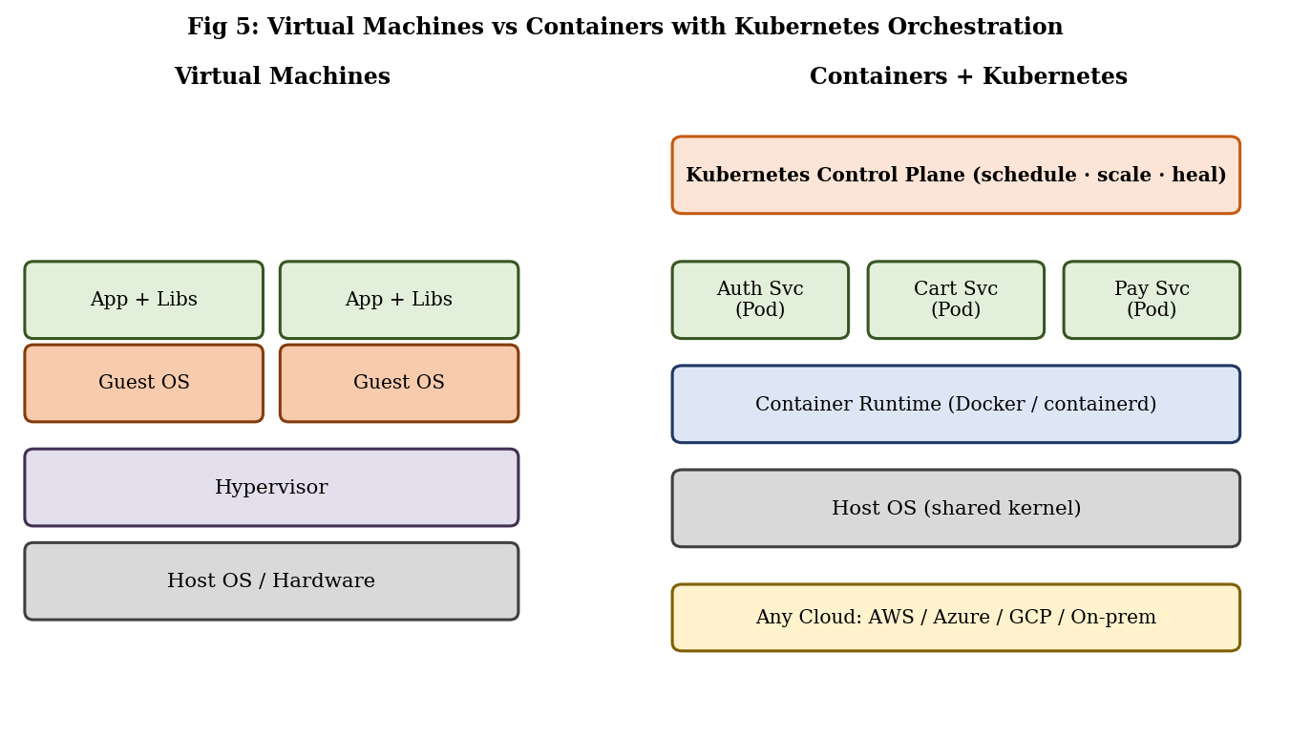
Fig 5: Virtual machines vs containers with Kubernetes
Parameter | Virtual Machine | Container
Architecture | Hypervisor + full guest OS per VM | Container runtime sharing the host OS kernel
Size | Gigabytes | Megabytes
Start-up time | Minutes | Seconds or milliseconds
Performance | Overhead from guest OS and virtualisation | Near-native performance, low overhead
Resource usage | High CPU/RAM per instance; fewer per host | Low; many more containers per host (higher density)
Isolation | Strong (separate OS kernel) | Process-level isolation; needs extra hardening
Portability | Tied to hypervisor/image format | Runs the same on any host with a container runtime
Best for | Legacy apps, different OSs, strong isolation | Microservices, CI/CD, rapid scaling

2. How Kubernetes Orchestration Simplifies Deployment and Scaling
When an application has hundreds of containers, managing them by hand is impossible. Kubernetes automates their lifecycle:
- Automated deployment: A declarative YAML file states the desired state; Kubernetes schedules the pods on suitable nodes.
- Auto-scaling: The Horizontal Pod Autoscaler adds or removes pods based on CPU or custom metrics; the cluster autoscaler adds nodes.
- Self-healing: Failed containers are restarted or rescheduled and unhealthy nodes are replaced.
- Rolling updates and rollback: New versions are released gradually with zero downtime and can be reverted quickly.
- Service discovery and load balancing: Services give stable names and balance traffic across pods.
- Configuration and secrets: ConfigMaps and Secrets keep settings and passwords outside the image.
Kubernetes term | Meaning
Pod | Smallest unit; one or more containers running together
Node | Worker machine (VM or physical) that runs pods
Deployment | Defines desired number of replicas and update strategy
Service / Ingress | Stable network endpoint and external routing with load balancing
Control plane | API server, scheduler and controllers that manage the cluster

3. Portability Benefits Across Cloud Environments
- Build once, run anywhere: The same image runs on a developer laptop, on-premise servers and AWS, Azure or Google Cloud, removing the “works on my machine” problem.
- Managed Kubernetes everywhere: Amazon EKS, Azure AKS and Google GKE use the same Kubernetes API, so manifests move with little change.
- Avoids vendor lock-in: Workloads can be shifted between providers or run in hybrid/multi-cloud setups for cost, compliance or disaster recovery.
- Consistent CI/CD: The same pipeline builds, tests and deploys the image to dev, test and production environments.
4. Example: Microservices-Based Application (Online Shopping)
Microservice | Function | Typical technology / data store
User / Auth Service | Login, registration, JWT tokens | Node.js + MySQL
Product Catalog Service | Product list and search | Java Spring Boot + MongoDB
Cart Service | Add / remove items, session cart | Python + Redis
Order Service | Create and track orders | Java + PostgreSQL
Payment Service | Payment gateway, transactions | Go + encrypted DB
Notification Service | Email / SMS / push alerts | Python + message queue

Each service is packaged in its own container, can be developed in a different language, deployed and scaled independently (for instance, the Cart and Payment pods are scaled up during a sale) and a failure in one service does not bring down the entire application. An API gateway/Ingress routes user requests to the right service.
Conclusion
Containers are lighter and faster than VMs, Kubernetes automates deployment, scaling and recovery, and container portability lets teams run microservices consistently on any cloud, making them ideal for modern application deployment.

